**FRIO COUNTY COMMISSIONERS COURT MINUTES FOR**

**Special called Meeting April 8th, 2025**

On the 8th day of April, 2025, at 3:00 p.m., the Commissioners Court of Frio County met in a special called meeting with the following members either absent or present, to-wit: Rochelle Lozano Camacho, Frio County Judge was present; Joe Vela, Commissioner Pct 1 present; Mario Martinez, Commissioner Pct 2 present; Raul Carrizales, Commissioner Pct 3 present; Danny Cano, Commissioner Pct 4 present; Joseph A. Sindon, Legal Counsel for Frio County Commissioners Court present; and Aaron Ibarra, Frio County Clerk present when the following meeting was held, to-wit: The meeting can be seen unedited and to its full extent on our county website, under the County Clerk tab.

I. Invocation and Pledge of Allegiance

II. Adopt Agenda

**AGENDA ADOPTED WITH THE REMOVAL OF PRESENTATION ITEM #2**

**MOTION: COMMISSIONER CARRIZALES**

**SECOND: COMMISSIONER CANO**

**MOTION PASSES**

III. Old Business

**PRESENTATION**

**ACTION AGENDA ITEMS**

IV. General Discussion

V. Citizens To Be Heard

VI. New Business

**PRESENTATION**

(1) Marta Salazar, BSN, RN, Public Health Nurse, Texas Department of State Health Services, requests., requests:

Presentation regarding the Frio County Public Health Activity Report, provide the Texas Department of State Health Services Region 8 2024 Annual Report, and distribute DSHS Brochures and answer questions proposed.

(2) Hon. Pete Jasso Martinez, Frio County Treasurer, requests:

Presentation regarding the 1st quarterly investment report of the Frio County Investment Committee.

(3) Hon. Ofilia Trevino, Frio County District Clerk, requests:

Discuss upcoming changes for issuing jury payments beginning May 2025.

**ACTION AGENDA ITEMS**

(1) Hon. Rochelle Camacho, Frio County Judge, requests:

Consider/take action to designate April 2025 as Child Abuse Prevention Month and approve resolution stating same.

**MOTION: COMMISSIONER CARRIZALES**

**SECOND: COMMISSIONER CANO**

**MOTION PASSES**

(2) Hon. Pedro “Peter” Salinas, Frio County Sheriff, requests:

Consider/take action on approving the sole source justification letter of license plate reader software from Vetted Security Company.

**MOTION MADE TO APPROVE ITEM AND ACCEPT THE SIGNED COPY FROM THE COUNTY AUDITOR.**

**MOTION: COMMISSIONER CARRIZALES**

**SECOND: COMMISSIONER MARTINEZ**

**MOTION PASSES**

(3) Hon. Crystal Marquez, Frio County Auditor, requests:

Consider / take action on approving quote Q-11378-1 from Vetted Security Solutions to purchase two Vetted License Plate Readers with trailers, for the Frio County Sheriff’s Office, to include dual feed trailer upgrades, Vigilant LPR basic hosted management package, Vigilant Partner System start up & commissioning LPR system, Vigilant LPR client software for non-host systems, 3-year TechAlert software license subscription, and shipping. This purchase will be funded by FY 2022 Stone Garden Program Grant, for a total cost of $84,595.42.

**MOTION: COMMISSIONER CARRIZALES**

**SECOND: COMMISSIONER CANO**

**MOTION PASSES**

(4) Hon. Pedro “Peter” Salinas, Frio County Sheriff, requests:

4.1 Consider/take action on approving the damaged property reimbursement request for Avant Ranch for property damage located at FM 117 and Hwy 85 in the amount of $1,000.00

4.2 Consider/take action on approving the damaged property reimbursement request for Avant Ranch for property damage located at Hwy 85 east in the amount of $1000.00

**MOTION: COMMISSIONER CANO**

**SECOND: COMMISSIONER MARTINEZ**

**MOTION PASSES**

(5) Ramiro Trevino, Frio County Human Resources Director, requests:

Consider/take action to appoint Reyes Leal III, as a member of the Sick Leave Pool Committee. Reyes is replacing former committee member, John Meyer.

**MOTION: COMMISSIONER CARRIZALES**

**SECOND: COMMISSIONER CANO**

**MOTION PASSES**

(6) Hon. Crystal Marquez, Frio County Auditor, requests:

Consider / take action on the acceptance of donated equipment totaling the amount of $25,284.00 from Target Logistics in conjunction with Core Civic to Frio County.

**MOTION: COMMISSIONER MARTINEZ**

**SECOND: COMMISSIONER CANO**

**MOTION PASSES**

(7) Hon. Crystal Marquez, Frio County Auditor, requests:

Consider/take action to enter into a Statement of Work between Frio County and Identity Theft Fraud Solutions, Inc. “IDX” for the provision of cybersecurity data breach response services.

**MOTION: COMMISSIONER MARTINEZ**

**SECOND: COMMISSIONER CARRIZALES**

**MOTION PASSES**

(8) Hon. Crystal Marquez, Frio County Auditor, requests:

Discuss and/or take appropriate action to certify the revenue received, $2,000.00 under the General Fund (fund 100) and add the following line items to the 2024-2025 Budget to receipt the funds and allow expenses:

Account #: 100-40000.4888 WELLNES PROGRAM

Account Name: REVENUES

Account #: 100-58611.5290 WELLNESS PROGRAM SUPPLIES

Account Name: H.R.

**MOTION: COMMISSIONER CARRIZALES**

**SECOND: COMMISSIONER MARTINEZ**

**MOTION PASSES**

(9) Hon. Crystal Marquez, Frio County Auditor, requests:

Discuss and/or take appropriate action to certify the revenue received, $161,936.86 under the Stone Garden Grant Fund (fund 105) and add the following line items to the 2024-2025 Budget to receipt the funds and allow expenses:

Account #: 105-40000.4350 STONEGARDEN GRANT FUND

Account Name: REVENUES

Account #: 105-50000.5105 SALARIES - DEPUTIES

Account Name: STONEGARDEN

Account #: 105-50000.5131 PAYROLL TAXES

Account Name: STONEGARDEN

Account #: 105-50000.5151 COUNTY RETIREMENT CONTR

Account Name: STONEGARDEN

Account #: 105-50000.5156 COUNTY RETIREMENT SUPPLE

Account Name: STONEGARDEN

Account #: 105-50000.5161 WORKERS COMP INSURANCE

Account Name: STONEGARDEN

Account #: 105-50000.5171 UNEMPLOYMENT INSURANCE

Account Name: STONEGARDEN

**MOTION: COMMISSIONER MARTINEZ**

**SECOND: COMMISSIONER CANO**

**MOTION PASSES**

**RECESS @ 4:08 PM**

**MOTION: COMMISSIONER CARRIZALES**

**SECOND: COMMISSIONER MARTINEZ**

**MOTION PASSES**

**RESUME @ 4:22 PM**

**MOTION: COMMISSIONER CARREZALES**

**SECOND: COMMISSIONER CANO**

**MOTION PASSES**

(10) Hon. Crystal Marquez, Frio County Auditor, requests:

10.1 Consider/take action to approve the budget amendments to the FISCAL YEAR 2024-2025 Frio County Budget, list below:

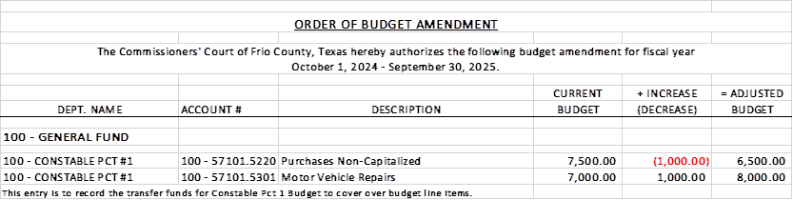

10.2 If the amendment is approved, consider/take action on signing order stating same.

**MOTION: COMMISSIONER CARRIZALES**

**SECOND: COMMISSIONER MARTINEZ**

**MOTION PASSES**

(11) Hon. Crystal Marquez, Frio County Auditor, requests:

11.1 Consider/take action to approve the budget amendments to the FISCAL YEAR 2024-2025 Frio County Budget, list below:

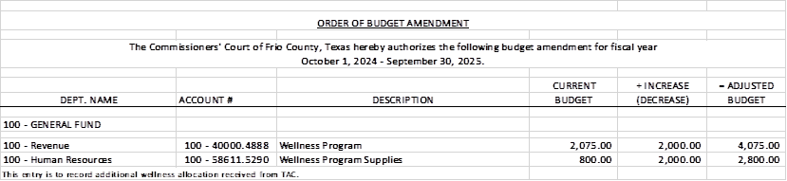

11.2 If the amendment is approved, consider/take action on signing order stating same.

**MOTION: COMMISSIONER MARTINEZ**

**SECOND: COMMISSIONER CARRIZALES**

**MOTION PASSES**

(12) Hon. Crystal Marquez, Frio County Auditor, requests:

12.1 Consider/take action to approve the budget amendments to the FISCAL YEAR 2024-2025 Frio County Budget, list below:

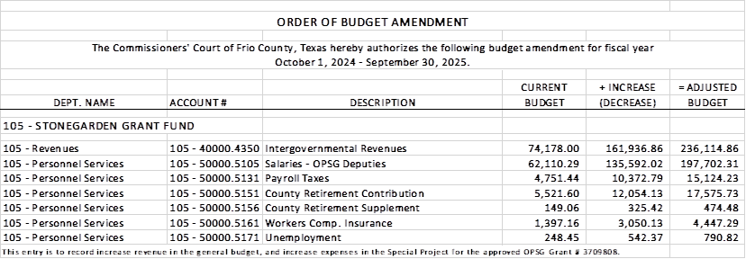

12.2 If the amendment is approved, consider/take action on signing order stating same.

**MOTION: COMMISSIONER CARRIZALES**

**SECOND: COMMISSIONER CANO**

**MOTION PASSES**

(13) Hon. Crystal Marquez, Frio County Auditor, requests:

13.1 Consider/take action to approve the budget amendments to the FISCAL YEAR 2024-2025 Frio County Budget, list below:

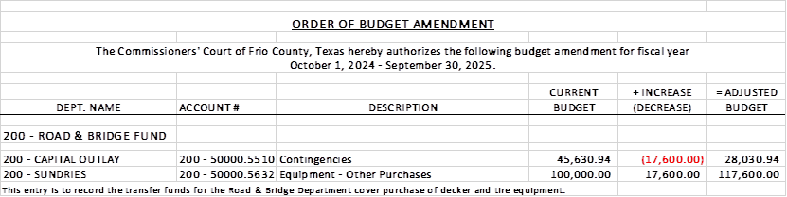

13.2 If the amendment is approved, consider/take action on signing order stating same.

**MOTION: COMMISSIONER MARTINEZ**

**SECOND: COMMISSIONER CARRIZALES**

**MOTION PASSES**

(14) Hon. Rochelle Camacho, Frio County Judge, requests:

14.1 Consider/take action to approve an interlocal agreement between Frio County and the Camino Real Community Services to provide and implement the Mental Health Officer-Co-Responder Program.

14.2 If the interlocal agreement is approved and adopted, then execute a resolution authorizing Frio County Judge Rochelle Camacho to execute the agreement on behalf of Frio County, Texas.

**MOTION: COMMISSIONER MARTINEZ**

**SECOND: COMMISSIONER CARRIZALES**

**MOTION PASSES**

(15) Frio County Commissioners Court, requests:

Receive in person from the following county officials the following reports as mandated by law:

15.1 Presentation by Frio County Treasurer of detailed report as mandated by Section 114.026, Local Government (“Code”) (this report is to be presented at each **regular term of commissioners court).**

15.2 Frio County Treasurer to exhibit the books and accounts of that office for the inspection of the commissioners court (**to be done at each regular term of commissioners court).**

15.3 Consider/take action on authorizing the execution by Frio County Commissioners Court (the Judge and each commissioner) of an affidavit stating the requirements of the treasurer’s report have been met as mandated by section 114.026 of the Code.

15.4 Consider/take action on execution of an order of the commissioners court approving the county treasurer’s report and order their publication in the Frio-Nueces Current as mandated by Section 114.026 of the Code or publication on the county’s website.

**MOTION: COMMISSIONER CARRIZALES**

**SECOND: COMMISSIONER CANO**

**MOTION PASSES**

(16) Frio County Commissioners Court requests:

Presentation, pursuant to Section 114.044 of the Local Government Code, by:

1. Frio County District Clerk;

2. Frio County Clerk

3. Frio County Treasurer

4. Frio County Attorney

5. Frio County Judge

6. Frio County Sheriff

7. Frio County Auditor

8. Frio County Justice of the Peace

9. Frio County Constables

**(who collects or handles any money for the use of the county) of all fines imposed, judgments rendered and collected, and all jury fees collected by the respected courts in favor of or for the use of the county and at that time when the reports are presented to present receipts vouchers that show disposition of the money, fines or judgments.**

After examination by the commissioners court as to the correctness of the reports, consider/action on directing the county clerk to enter information in county finance records as mandated by Section 114.044 of the Code.

**MOTION: COMMISSIONER CARRIZALES**

**SECOND: COMMISSIONER MARTINEZ**

**MOTION PASSES**

(17) Documents (resolutions, orders, contracts, etc.) to be signed.

(18) Allow bills payable

**MOTION: COMMISSIONER CARRIZALES**

**SECOND: COMMISSIONER CANO**

**MOTION PASSES**

(19) Adjourn

**MOTION: COMMISSIONER CARRIZALES**

**SECOND: COMMISSIONER MARTINEZ**

**MOTION PASSES**